**Analysis of London Housing Prices from 2000 to 2020**

From 2000 to 2020, average prices of homes in London have increased almost equally across all London boroughs. The bar charts for both 2000 and 2020 are similar.

|  |  |
| --- | --- |
| *Average prices (2000)* | *Average prices (2020)* |

The following London boroughs have seen the greatest increase in housing prices from 2000 to 2020

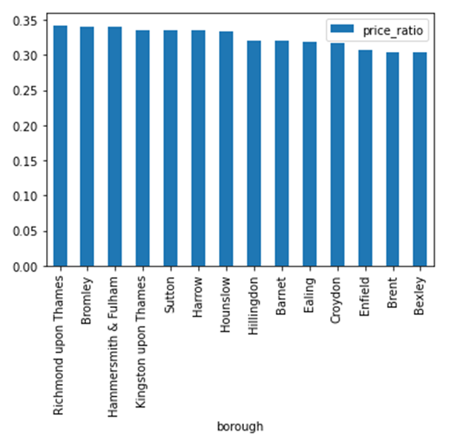1. Richmond upon Thames

2. Bromley

3. Hammersmith & Fulham

4. Kingston upon Thames

5. Sutton

6. Harrow

7. Hounslow

|  |  |
| --- | --- |
| *Average prices 2000 (sorted)* | *Average prices 2020 (sorted)* |

Kensington & Chelsea remains the most expensive borough followed by Westminster.

Barking & Dagenham remains the least expensive London borough.

City of London and Camden were more popular than Hammersmith & Fulham in 2020

